Issue 16 of our Parish and Communities update can be found below.

Please continue to let us know what you think, your feedback is important to us and will allow us to improve our services to you.
___________________________________________________________________

NEWS
Swift Action for Swifts
- Volunteer for Leicestershire & Rutland Ornithological Society (LROS) to check the nest box sites for activity.
- Eligibility checker Homes Upgrade plus Swift box Green Living Leicestershire Home Upgrade Grant (HUG) | Leicestershire County Council
- Register for a nest box and a bird caller environmentteam@leics.gov.uk

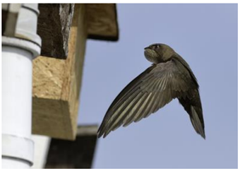
___________________________________________________________________

REMINDERS
- The urban grass cutting programme started on 2nd April and there will be 6 cuts until 29th September, dates are always subject to weather. All dates can be checked by using our online search function. A new weed spraying contractor has been appointed on a 3-year contract. The first treatment being carried out throughout May and June with the second treatment happening later in the summer. More info is available on our website.

- All waste sites have now moved to the summer opening hours until 30th September 9am to 7pm. Visitors are encouraged to arrive 10 minutes prior to closing, last admittance being 6.55pm.

- Details of weekly planned roadworks throughout Leicestershire can be found here. This is updated every Monday and shows the following 10 days, please note this is only up to date at the time of creation and will not contain information on emergency works, however this can be found on the one.network site.

- To log an enquiry, we would ask that you use the ‘Report a problem’ online form wherever possible - this form guides you through the identification and location of the issue, allowing easy input of the relevant data. You do not have to log in or have an account to do this and you will receive an acknowledgement, reference number, and receive regular updates on the issue reported.

- For all other enquiries that do not fit into the ‘Report a problem’ form, please submit these using the exclusive email address 'CSCparishes@leics.gov.uk, this was introduced several years ago to ensure that Parish Councils and Community Organisations are provided with a consistent and centralised approach.
_____________________________________________________________

Information on local services, latest news and events can also be found on our Information for parishes and communities webpage and LCC website.

Contact the Special Projects Team, Environment and Transport Department on 0116 305 5186 or at etdspecialprojects@leics.gov.uk

