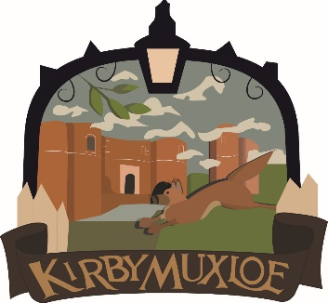

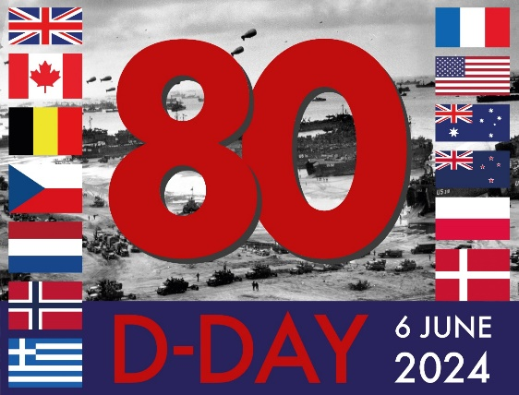

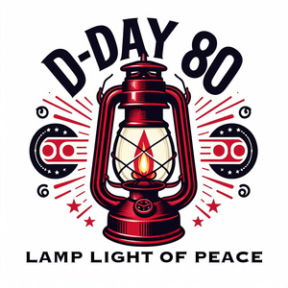
THURSDAY 6TH JUNE 2024
9.15PM – LIGHTING OF LAMP LIGHT OF PEACE
TOGETHER WITH A READING OF
“THE INTERNATIONAL
TRIBUTE”

You are welcome to join us in the lighting of the Lamplight of Peace in commemoration of the 80th Anniversary of the D-Day Landings to be held at the War Memorial Gates, Station Road, Kirby Muxloe

